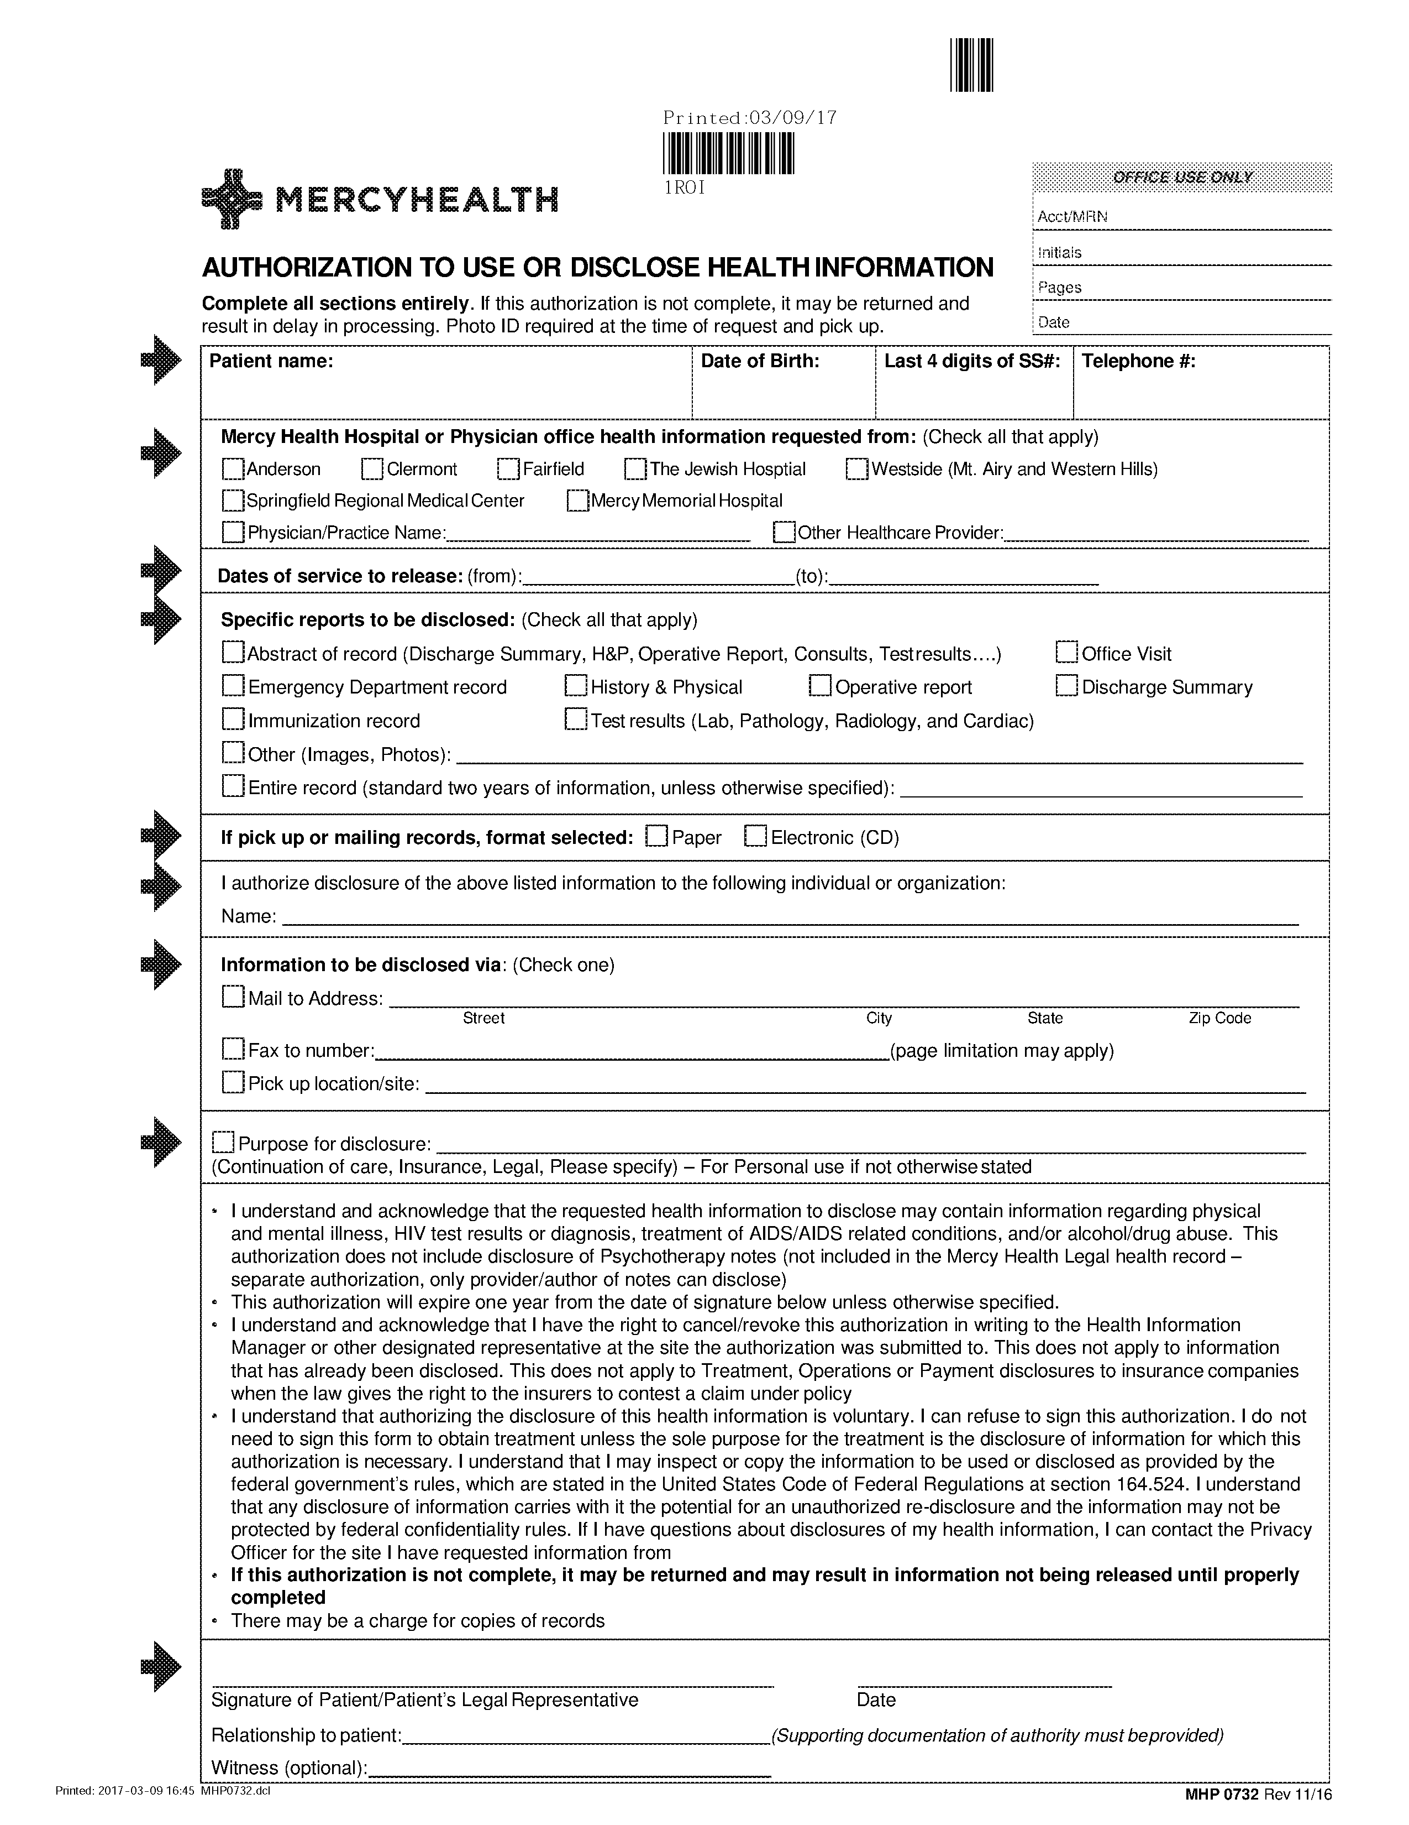
Batman
01/01/1979
Axiom Requisition Copy Service
2869 Jolly Road

Okemos MI 48864
FROM 01/01/1979 TO PRESENT: Any and all MEDICAL RECORDS, including but not limited to patient history form(s), reports, etc. pertaining to Batman SSN: xxx-xx-5555, DOB: 01/01/1979.
X
X
xxx-xx-5555
University of Michigan Hospital and Health Center Release of Information Unit
Release of Information Unit - NCAC
2901 Hubbard Street Room 2722
Ann Arbor, MI 48109-0000
X
Legal

